BYU Student Nurse’s Association  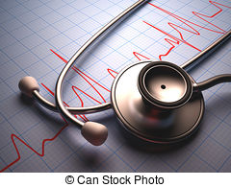  The Pulse  Fall 2019  NLC Celebrates 5 years!  NLC Open House for Anniversary  The NLC Open House on Friday, September 13th celebrated the 5th anniversary of the NLC remodel. The rebuild cost approximately $4 million, and the open house showcased to the amazing technology BYU nursing students learn on and enjoy. A scavenger hunt lead guests through each room of the NLC where they participated in activities like learning to use a stethoscope on SAM, our Student Auscultation Manikin, having a conversation with one of our high fidelity manikins, or learning | UPCOMING EVENTS  ────  Scholarship Applications (see email for Cara Wiley for all dates)  ────  SNA Giving Tree Now - Dec. 12th  ────  SNA T-shirt clearance going on NOW!  Content  - NLC Open House  - Night of Naloxone  - Days for Girls  - High Fitness and Food Drive  - Alumni Global Health Kits  - Days for Girls  - SNA Giving Tree  - SNA Scholarships  - Letter from the Editor  - Nursing Funnies

Naloxone. It saves lives. Naloxone (Narcan) is a life-saving measure to reverse opioid overdose. No one is exempt from being at risk. Infants, children, adults, elderly and pets at risk for opioid overdose especially with Utah being one of the highest opioid-using states. On October 1st, BYU SNA nursing students, under the direction of Utah Naloxone, were trained to identify common opioids and how they function in the body, the signs of opioid overdose, and how to administer naloxone, as a reversal antidote to opioid overdose. It was an informative and thorough 2-hour end-user training aimed to equip each student with the understanding and practice of how to respond before a patient or loved one with opioid overdose. At the end of the meeting, each student received a naloxone kit to take home with them. Overall, it was a spectacular training that many students felt solidified their understanding of Naloxone as an antidote to opioid overdose.
For those who couldn't attend, here's a generalized breakdown of what was mentioned: Common opioids, not all inclusive: Codeine, Hydrocodone, Morphine, Oxycodone, Fentanyl. S/Sx of opioid overdose: pinpointed pupils, slowed respirations (<12), cyanosis, limp body, unresponsiveness, etc. Many cases, unfortunately result in death, when it is 100% preventable!
Naloxone (Narcan) reverses opioid overdose. If you aren't sure if the person is overdosed, administer Narcan anyway; Narcan will not hurt them. If they are overdosed, you just saved a life!

basic CPR on a manikin. There was also the amazing opportunity to witness an engineering wonder, the NLC birthing manikin. There were many other activities to enjoy, like seeing a student make fake blood, using a black light to find out how well you are washing your hands or shouting "I love BYU nursing!" The guests got some awesome BYU Nursing SWAG and pizza for participating. The NLC is not normally open to the public, so this was a unique opportunity for public to explore our wonderful facility.
This amazing logo created by Zak Gowans. It was given away on T-shirts as a prize for open house participants and was a hot commodity. Look for it at the SNA sales table soon!
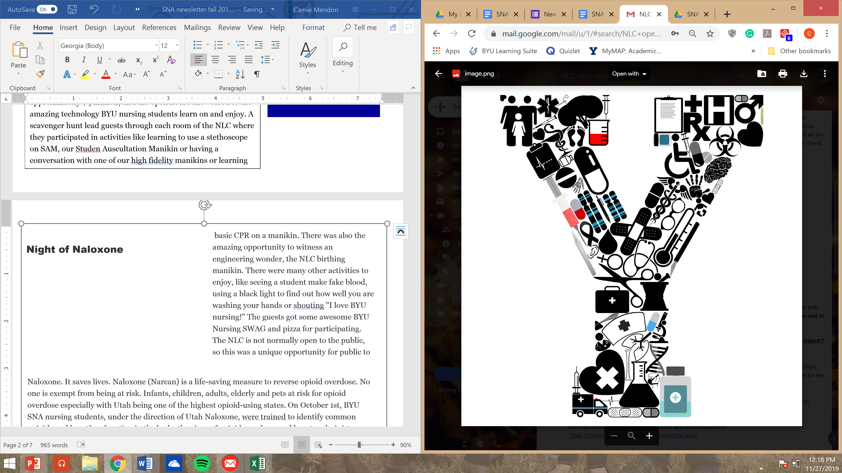
Night of Naloxone



outing out of it. In addition to a great service and networking opportunity, students were fortunate to have Jenny, an energetic instructor from the Provo Rec Center. At the end of the activity, 6 lucky raffle winners took home a prize—one of three pies or one of three college of nursing t-shirts.
Exercise and service-- what a combo! On November 15th, 2019 over 30 students from the College of Nursing participated in a high fitness activity which secondary purpose was to gather canned food for the Community Action Center in Provo. Each canned item or non-nursing student counted to enter the raffle to win a prize at the end of the activity. Several students brought dates and made a high-energized outing out of it. In addition to a great service and networking opportunity, students were fortunate to have Jenny, an energetic
The BYU SNA Days for Girls event was very successful! Sixty-nine people RSVP-ed, 46 SNA members came to the event, 15 girls and 4 staff members from New Haven (a residential treatment center) participated, and other nursing students, friends, and walk-ins helped make the feminine hygiene kits. We enjoyed bagels, fruit, and smooth jazz as we worked on the kits. The activity was scheduled from 9 AM to 12 PM, but supplies ran out almost an hour before 12 PM! The Days for Girls representative, Jordan, shared a presentation

Days for Girls
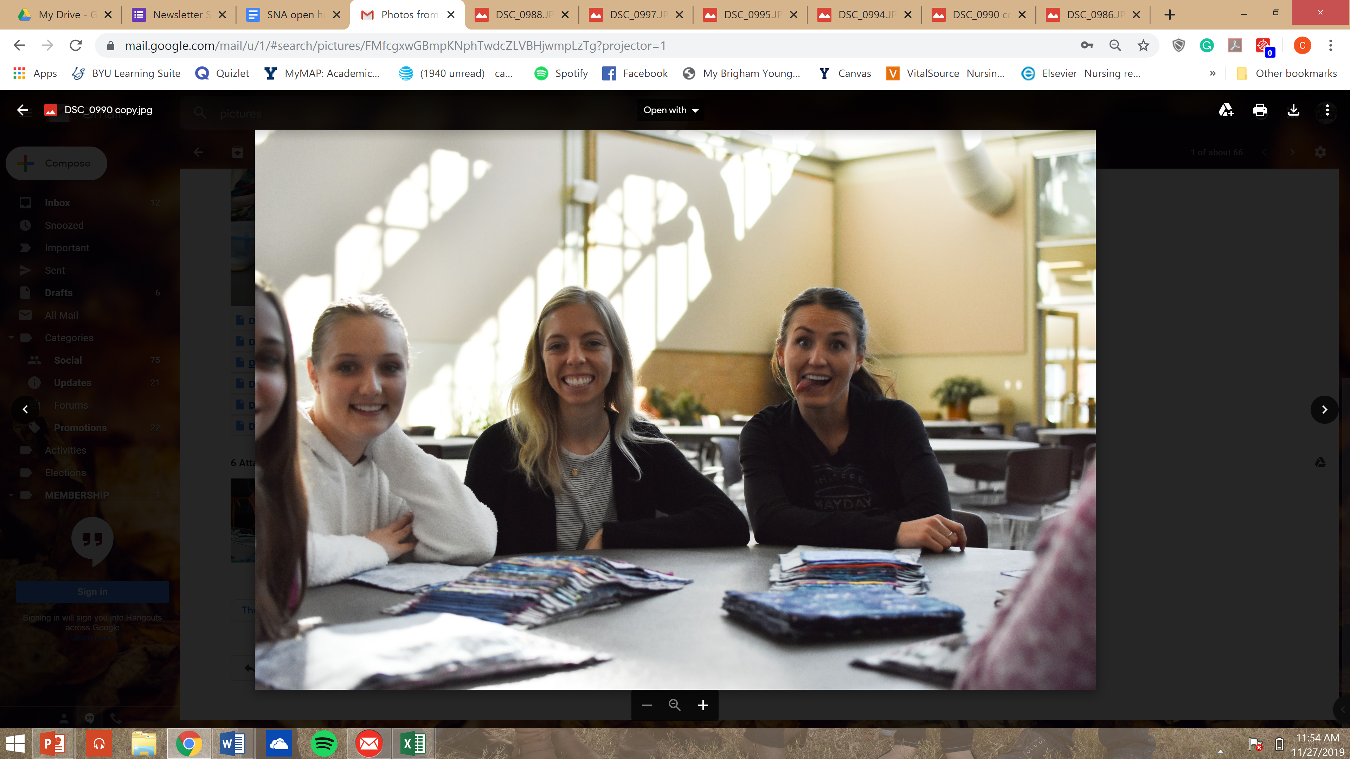
about how Days for Girls started, how benefits girls in other countries. She asked a few nursing students to share what their experiences were like giving out Days for Girls kits and teaching girls in other countries while doing the Global Health study abroad. We are excited to do this activity again in January!
High Fitness and Food Drive
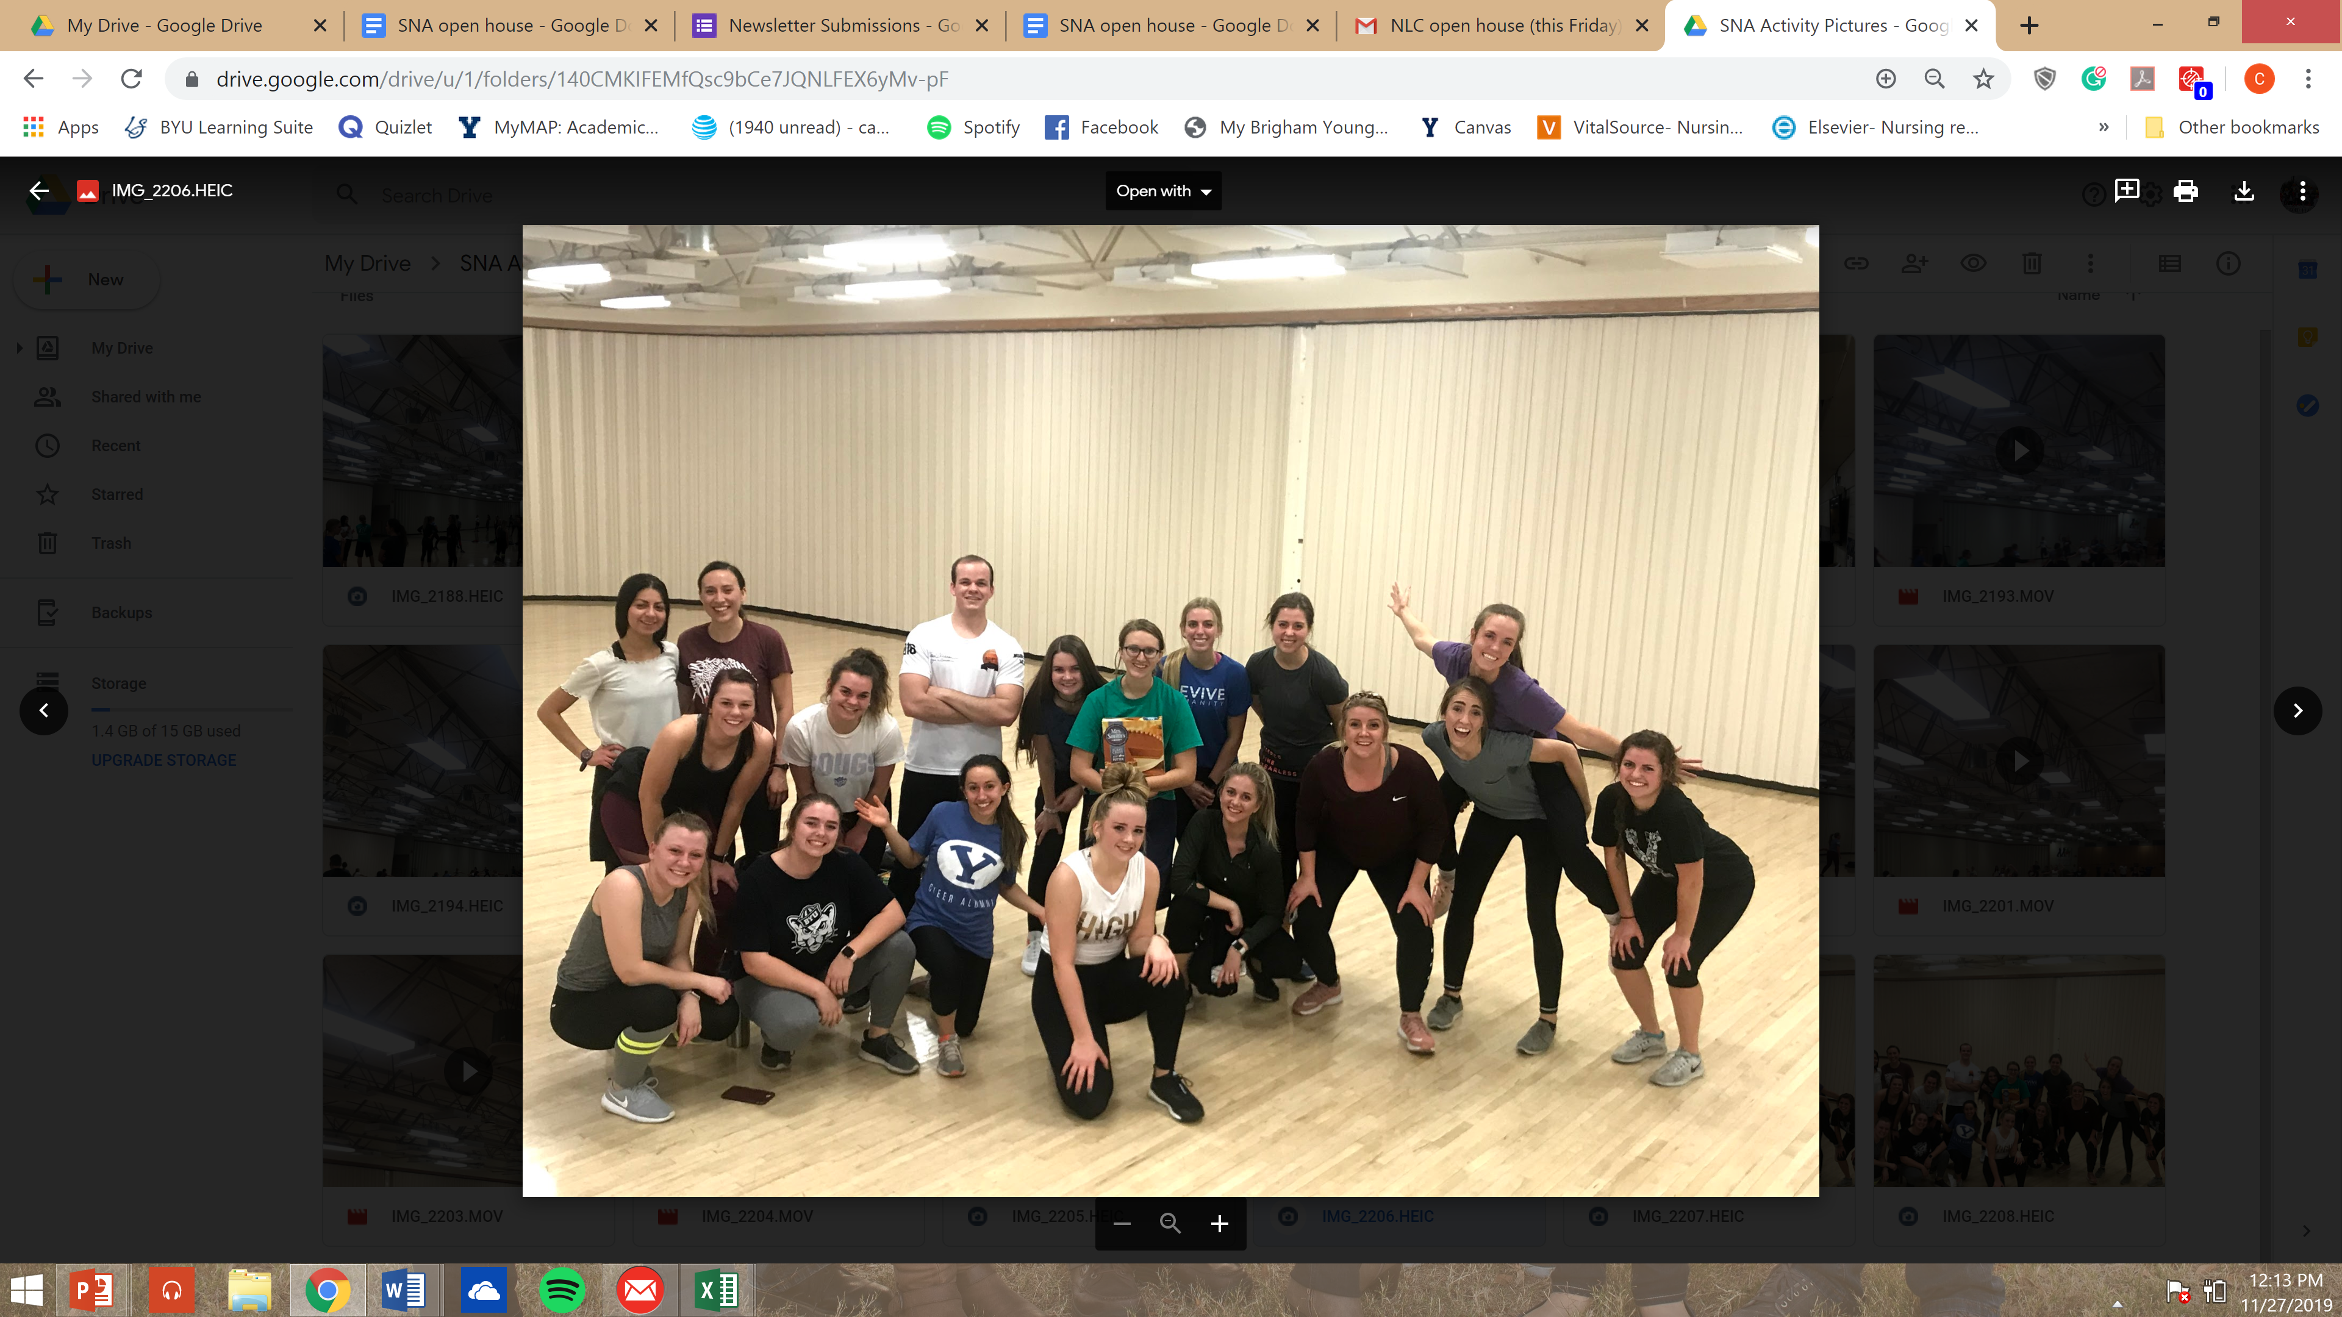

Alumni Global Health Kits
The annual BYU Nursing Alumni Global Health Kits held during Homecoming Week allowed BYU nursing students to network with BYU CON alumni as they put together health kits to be taken on the BYU Nursing Global Health trips this upcoming Spring. During this activity nursing students put together 938 dental kits filled with toothpaste and toothbrushes, 310 hygiene kits filled with soap and washcloths, and 520 first aid kits filled with alcohol wipes, antibiotic ointment, bandaids, and soap. This annual event is always a favorite of students.

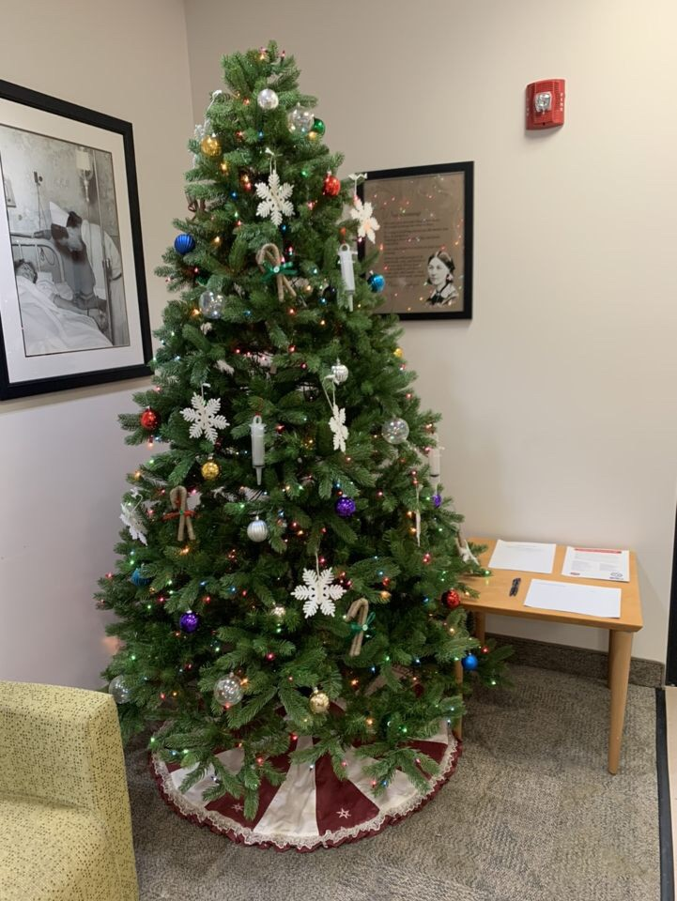
SNA Giving Tree
BYU SNA has partnered with United Way to provide an opportunity for BYU
nursing students and faculty to participate in Sub for Santa. Collecting both
children's toys and children's books, SNA is hoping to provide families in
Utah County with Christmas presents this holiday season. This activity is
being held in the NLC until December 12th, and anyone is able to participate!
Come give back this Christmas season!
SNA SCHOLARSHIPS!
Did you know that last year only six people applied for the five $500 BYU
Student Nurses' Association scholarships?? This year we want to make sure
we spread the word like we want to spread the flu...vaccine!!! Applications to
apply for SNA scholarships open March 1st and close March 31st. Scholarship winners are chosen based on a point system. Points are awarded for: Attendance to BYU SNA Activities this year, professional nursing development, and 1 page written essay. These scholarships are open to all SNA members EXCEPT current members of the SNA board. More information and FAQs can be found at
https://nursing.byu.edu/students/SNA/scholarship.aspx
Letter from the Editor
My name is Camie Mendon and I am a fourth semester nursing student. I am from Northern California and last year the town of Paradise, where we had many friends, family, and our business, was burned to the ground in the devastating Camp fire. There were many factors which contributed to this becoming the deadliest fire in the US in the last century. It struck small satellite towns and north east paradise first- where the hospital was located. With a failure in communications and the incredible speed of the fire, the hospital was under evacuation while the fire slowly surrounded them and burned at the perimeter. Thanks to the heroic effort of the staff, everyone made it out alive. Staff who were interviewed said there were nurses and doctors a like pulling up their SUVs and cars, shoving patients and staff inside, throwing out their children’s car seats in the parking lot. Several nurses took made multiple trips back and forth to transport patients, almost dying in the process.
Obviously, this was an extreme disaster situation. However, as the anniversary passed and I reflected on it, I wanted to take the chance to share some thought I have had recently regarding our calling as nurses- because I do feel like it is a calling from our Heavenly Father. Our jobs are so much more than to just fixing broken bones and diseased bodies. We are there on the best or worst days of people’s lives. For some, we are there when their personal “Paradise” is burning to the ground, and what a sacred privilege that is. It is a privilege to be able to share our compassion with them, to give them hope, to help them heal, to share in their sorrows or their joys. We may not have to go to the extreme lengths that those in the Camp Fire did , but we can do small things everyday for both our patients and those around us. We can take the time to share a smile, sit for an extra moment to talk, or help a stranger in need. As we do so, we will truly be embodying what it means to learn the Healer’s Art.
For more information and stories on the Camp Fire, watch “Fire in Paradise” on Netflix
Nursing Funnies
