BYU Student Nurse’s Association    The Pulse  Fall 2018  an “inspired” homecoming!  SNA Float Wins the Dean’s Award!  What started out as a nursing pun ended up being an award-winning float! Saturday October 13th, nursing students from various semesters pulled their labor, tools, and creativity together to create the respiratory themed float for the “Be Inspired” BYU homecoming theme. Winning the Dean’s Award for Best College/Department Entry. SNA advisor Bret Lyman drove the float while 5 students walked in the parade, handed | UPCOMING EVENTS  ────  Healthy Student Nurses November Submissions due November 3rd at NOON  ────  SNA Giving Tree Now-Finals  ────  Candy Grams Now-Finals (buy at the sales table Mondays and Fridays)  Content  - BYU Homecoming  - Healthy Student Nurse’s Challenge  - Research Night  - Summer Experiences  - Days for Girls  - Letter from the Editor  - Nursing Funnies

The Healthy Student Nurse Challenge (HSNC) is a goal-oriented, semester-long activity that was inspired by the American Nurses Association's Healthy Nurse, Healthy Nation™ Grand Challenge. We want to encourage student nurses to make a lifelong habit of making healthy choices, since healthy nurses (and future nurses!) can influence the health of the nation. To be involved with HSNC, nursing students make and keep a goal for each month and are entered into drawings for prizes such as a massage, a Camelbak daypack, or a Fitbit! The semester with the highest participation will also win a pizza party. Students have reported better physical health and stress management, as well as practice making long-term goals for their health. (to the right, Izzy Allgaier, 2nd semester)

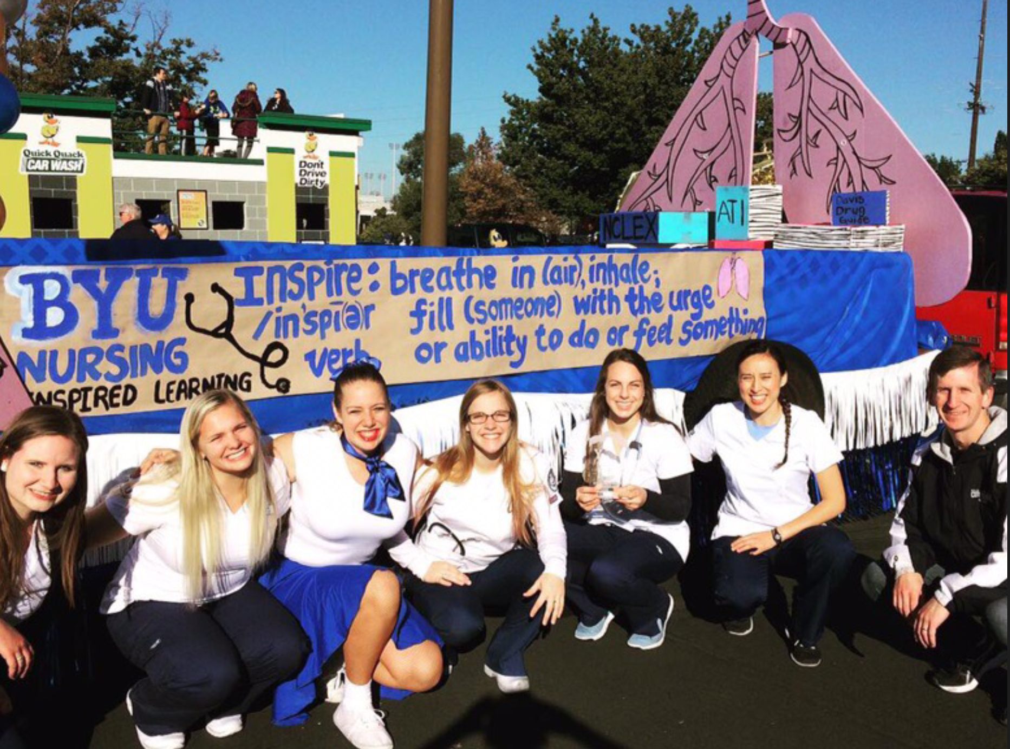
Healthy Student Nurses’ Challenge
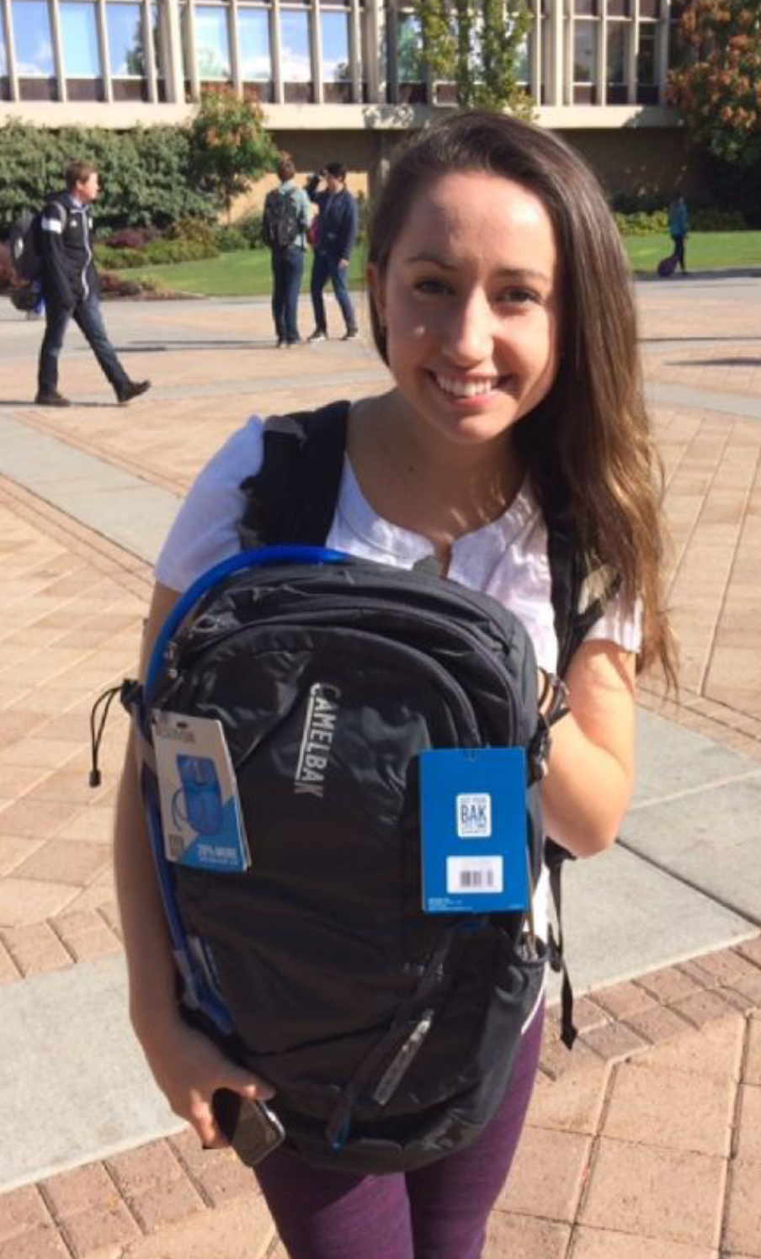
Research Activity
October 9th we had a research activity where 8 professors came and taught us about the importance of research as well as their areas of interest. There were also 3 Research assistants who explained how research has helped them to gain more opportunities in nursing school and build their resumes. Afterward, students were able to enjoy some light food and talk to professors one-on-one about their research and opportunities they could get involved in. If you are interested in applying to be an RA, go to this link and fill out an application: https://nursing.byu.edu/MyTasks/Forms/FormManager.aspx
To know what research is currently being done and which professors are doing it, go to this link:
https://nursing.byu.edu/research/FacultySpecialties/default.aspx
Summer Experiences
With internships, study abroad, classes, jobs and more, it’s never too early to start thinking about your summer plans- here is one student’s nursing experience over the summer:
Emily Crow, 5th semester -“I had the awesome opportunity this summer to participate in the Veterans Affairs Learning Opportunity Resident (VALOR) program. The VALOR program is a paid student

out candy and fliers and overall had a great time interacting with the people gathered to watch. The float was a crowd favorite as people shouted, “We love our nurses!” and other thanks and praises for their nurses and students. The BYU homecoming parade is a fantastic and fun way to not only get involved with SNA and the college of nursing, but also to be involved as a BYU cougar and have an unforgettable college experience. We hope to see you all there next year!

Days for Girls is an organization that goes to over 120 countries on every continent educating girls about proper feminine hygiene and health. They also bring kits with reusable pads so that women and girls have dignified ways to manage their periods. Saturday November 10th, we had the opportunity to help make some of the kits that will be going with students to Ecuador and Ghana this Spring. We had about 40 students, family, and
nurse clinical experience similar to rotations that you do during nursing school. I worked full-time for 10 weeks out of the summer with a nurse preceptor to practice nursing skills, such as assessment, documentation, medication administration, and interdisciplinary communication. I was assigned to the Acute Surgery unit in the VA’s hospital in Salt Lake. Not only did I gain greater confidence in my nursing abilities, I also felt more competent at recognizing the needs of my patients and what was within my power to do for them. The VALOR program is an amazing opportunity to work with an inspiring and frankly underserved group of people and prepare to be a better nurse in the future.”
Days for Girls
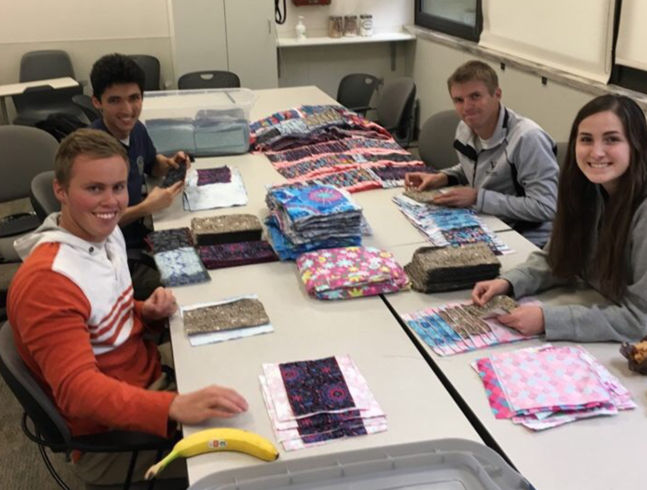
friends show up. People cut fabric, liners, ironed, and layered the kits and got everything ready to sew. We made 162 kits in 2 hours. The kits will be sewn up by professionals and brought back for our students to take on Public & Global Health. Our goal is to make 350 kits, so if you didn’t have an opportunity to participate this time keep an eye out for next semester!
Letter from the Editor
My name is Camie Mendon and I am in my second semester. I want to share a thing or two I learned this semester about good, better, best. Recently I have had many great opportunities come my way, but also more responsibilities. I thought, “These are all really good things to do, I can do all of it.” So, I found myself trying to balance school, a job, callings, relationships, mental and physical health, spirituality, extra-curriculars and the stress of big life decisions. As students we have busy lives, and sometimes (like myself) we think we can doing everything all at the same time. What I saw happen with myself is that either something would start to slip through the cracks, or my performance in all areas declined. While it is good to be engaged in a lot of good things, sometimes we need to decide if certain activities are the best thing we can be doing with our time. Logically, we know we can’t do everything, but how do we choose? Luckily, we also know that God can help us find out, through prayer, personal revelation, and sometimes taking a step of faith when we aren’t 100% sure. All in all, I learned that there are a lot of great things to do out there- but we don’t have to do them all right now, and we don’t have to do it all perfectly. What will never change though is the promise from President Nelson that, “as you consistently give the Lord a generous portion of your time, He will multiply the remainder.”

Nursing Funnies
